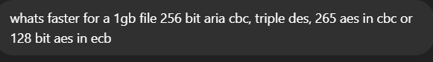
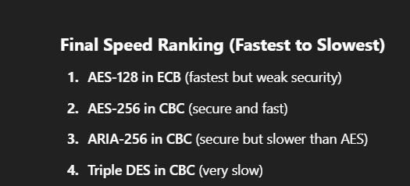
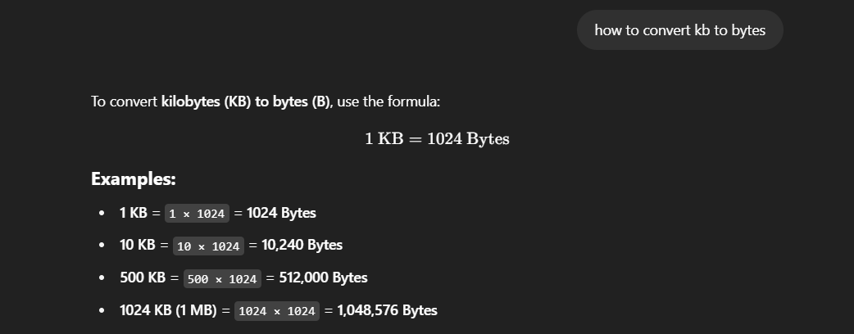
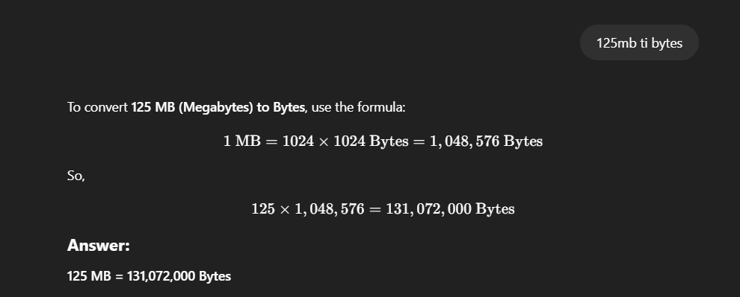
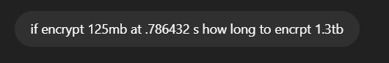
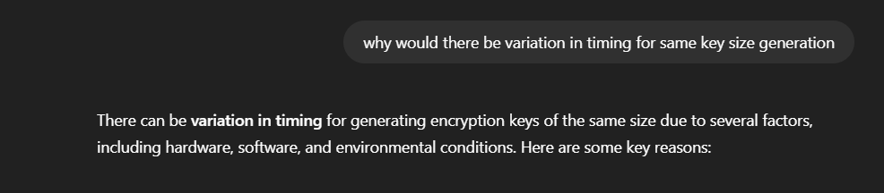
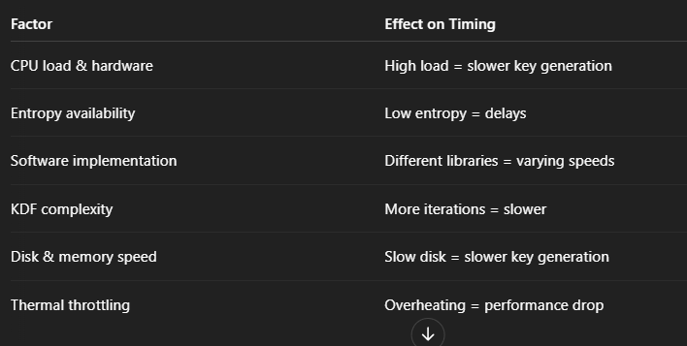
What Is Meant by revocation
when you make a key invalid so that they can no longer be used
why is it difficult of guarantee effective revocation with gpg
you can store your key on public servers but you have to revoke them on he public servers also
padding was likely added as there was not a full block of data so the padding filled this space

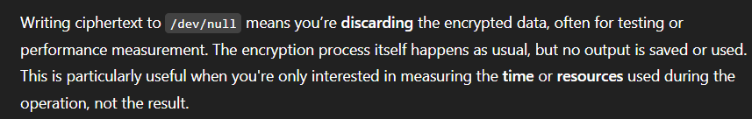
Cipher text block is likely corrupted so when decrypted loses like this
CBC as 1 block and 1 byte were corrupt

Explain the impact on performance experiments of writing ciphertext output to /dev/null.
It doesn’t save what you create or do but it still takes the command an execute it like normal

